# 7-2 Project Two README

# Joel Garcia

# SNHU CS 340

## About the Project/Project Title

Grazioso Salvare CRUD database and Python module (working title) is a project that can store and access rescue animal information. The data attributes can then be used to determine rescue-animal training eligibility.

## User Requirements

Grazioso Salvare is an animal rescue training company that seeks to identify dogs that are good candidates for search-and-rescue training. They commissioned this project to develop software that can create and access a database of rescue animals that can be used to determine training candidates with a higher chance of success. Customer requires that animals can be added, searched, updated, and removed. Customer also requires filtering options that can be used to sort for specific types of rescue animals. Finally, customer requires visual features such as graphs and map displays.

## Getting Started

To get a local copy up and running, follow these simple example steps.

1 – Upload the animal data into the local mongo database.

2 – Set up database users.

3 – Use the Python module and script to insert and read entries.

## Design Tools and Rationale

* Be sure to explain why MongoDB was used as the model component of the development, including what specific qualities or capabilities it provides for interfacing with Python.

I used MongoDB because I was told to. I know I’m supposed to come up with some sort of fictionalized rationale but I’m not a Mongo salesman and my energy is at 0. The course told me to use Mongo, I used Mongo. I’m sure any other DB architecture would have worked too.

* Be sure to explain the Dash framework that provides the view and controller structure for the web application.

There’s a table, pie chart, and map. Filter options update the output of each.

* Be sure to include links to any resources or software applications that were accessed or used.

https://learn.snhu.edu/content/enforced/1374842-CS-340-R1894-OL-TRAD-UG.23EW1/course_documents/CS%20340%20Dashboard%20Specifications%20Document.pdf?_&d2lSessionVal=ScQoRYLN9OTGv4T9RbCyYwie6&ou=1332057&_&d2lSessionVal=IJKGmk545cwOQRKOEzGe27Q0s&ou=1374842

## Features and Functionality

* Interactive filtering options
* Interactive data table
* Data charts

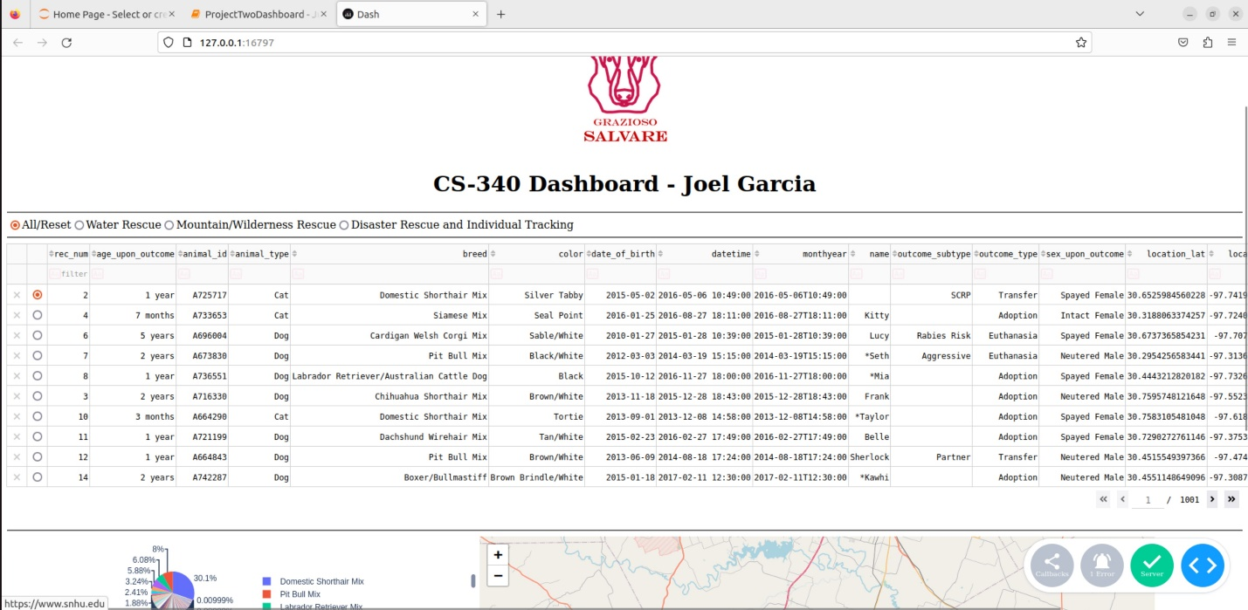

*Default Dashboard*

*Filtering for Water Rescue*

*Filtering for Mountain/Wilderness Rescue*

*Filtering for Disaster Rescue and Individual Tracking*

*Reset to Default*

**Steps Taken to Complete Project:**

Honestly all I did was go through all the FIXMEs in the provided template. As I built up each new bit of functionality I would go through the previous steps to make sure all my variables etc matched.

**Challenges Encountered:**

The biggest challenge, aside from the lack of time for this assignment due to my hectic schedule, was making sure all the different sections of functionality matched. Each week I was building pieces onto this software and because my personal life is so hectic right now, I would complete an assignment then forget about everything until the next week. Each week I would return to things and add more, and the ways I chose to implement things didn’t always match what I had done the previous week. This cause me to have to chase down various errors related to referencing things I renamed or trying to call older versions of functions that no longer existed. Because I added so much in this final project, this challenge was more apparent to me than in previous weeks. Aside from this, the template was pre-filled well enough and provided clear enough documentation that it wasn’t that difficult.

## Contact

Your name: Joel Garcia